UNITED STATES
SECURITIES AND EXCHANGE COMMISSION
Washington, D.C. 20549

FORM 6-K

REPORT OF FOREIGN PRIVATE ISSUER
PURSUANT TO RULE 13a-16 OR 15d-16 UNDER
THE SECURITIES EXCHANGE ACT OF 1934

For the month of May 2026

Commission File Number: 001-42727

HOTEL101 GLOBAL HOLDINGS CORP.
(Name of Registrant)

20 Cecil Street #04-03
Plus Building
Singapore 049705
(Address of Principal Executive Office)

Indicate by check mark whether the registrant files or will file annual reports under cover of Form 20-F or Form 40-F.

Form 20-F ☒ Form 40-F ☐

Exhibit  Number |  | Description of Exhibit
99.1 |  | Press Release, dated May 19, 2026

1

SIGNATURES

Pursuant to the requirements of the Securities Exchange Act of 1934, the registrant has duly caused this report to be signed on its behalf by the undersigned, thereunto duly authorized.

 | Date: May 19, 2026
 | HOTEL101 GLOBAL HOLDINGS CORP.
 | By: | /s/ Marriana H. Yulo
 | Name: | Marriana H. Yulo
 | Title: | Authorized Signatory
 | By: | /s/ Rodolfo Ma. A. Ponferrada
 | Name: | Rodolfo Ma. A. Ponferrada
 | Title: | Authorized Signatory

[Signature Page to Form 6-K]

2

Exhibit 99.1

Today: Hotel101 Global Reaches Record Single-Day Revenue Generation at 100% Occupancy in Hotel101 Madrid

Hotel101-Madrid generates over €100,000 in single day recurring room revenues today

Over 80% of hotel guests in the 680-room Hotel101-Madrid are from Europe, North America and Latin America

Hotel101 Madrid serves as the global prototype for Hotel101 Global and functions as the primary operating springboard for the company’s international expansion, which management expects to enable the successful replication of its innovative business model. This prototype supports Hotel101 Global’s vision of developing one million standardized rooms across 100 countries, with the ultimate goal of becoming the world’s largest single-brand hotel chain.

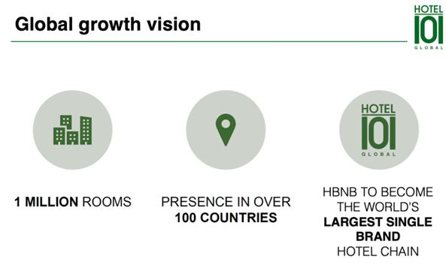

SINGAPORE, May 19, 2026 – Hotel101 Global Holdings Corp. (NASDAQ Ticker: HBNB) (“Hotel101 Global,” “Hotel101,” “HBNB” or the “Company”) today announced that its 680-room Hotel101-Madrid has significantly outperformed management’s original estimates, achieving a company record of more than €100,000 in room revenues in a single day on May 19, 2026, at 100% occupancy.

Management believes this record performance underscores the accelerating momentum and exceptionally strong demand for the 680-room Hotel101-Madrid, the first Hotel101-branded property to operate outside the Philippines, which officially opened in March 2026. This record single-day performance at 100% occupancy provides support for demonstrable, strong demand for the property and illustrates the property’s potential to generate substantial recurring revenues This milestone revenue achieved today of more than €100,000 Euros for a single day is expected to translate to a highly sizable recurring hotel revenues annually, further validating the success of the Company’s asset-light, prop-tech hospitality model and its focus on long-term recurring revenue generation from the Hotel101 global portfolio.

Hotel101-Madrid has been designated as an “Official Hotel” partner for the Formula 1 Spanish Grand Prix from 2026 to 2035 through an exclusive agreement with MATCH Hospitality AG. Hotel101-Madrid is one of the top five largest hotels in Madrid by room count. Located on a 6,593-square-meter site in Valdebebas, Madrid, it is strategically positioned, adjacent to the new Formula 1 Spanish Grand Prix circuit, overlooking the iconic semicircular Turn 12 titled “La Monumental”. The property offers convenient accessibility, located approximately a three-minute walk to Valdebebas Train Station, four minutes to the IFEMA convention complex, five minutes to the Real Madrid Sports Complex and seven minutes to the Adolfo Suárez Madrid-Barajas International Airport.

The hotel features modern amenities, including an all-day dining restaurant, HBNB Kitchen by award-winning La Sucursal, two swimming pools, a fitness center, a children’s playground, 24/7 reception, a business center, function rooms and a proprietary Hotel101 app that supports seamless guest services, including digital check-in and digital key access.

Hotel101 Madrid serves as the global prototype for Hotel101 Global and functions as the primary operating springboard for the company’s international expansion, which management expects to enable the successful replication of its innovative business model. This prototype supports Hotel101 Global’s vision of developing one million standardized rooms across 100 countries, with the ultimate goal of becoming the world’s largest single-brand hotel chain.

About Hotel101 Global

Listed on Nasdaq (Ticker: HBNB) with a market capitalization of approx. US$1.5 billion as of May 19, 2026. Hotel101 is an asset-light, prop-tech hospitality platform pioneering a global standardized "condotel" business model. Hotel101 aims to disrupt the global hotel and hospitality sector through its unique tech-enabled business model that positions it to generate revenues twice: first from the advance sale of individual hotel units during the construction phase; and second, from long-term recurring revenue derived from day-to-day hotel operations. The expansion of Hotel101 towards its long-term goal and vision to operate 1 million rooms in 100 countries globally is expected to be driven mainly by joint ventures and license agreements with local developers in various countries worldwide.

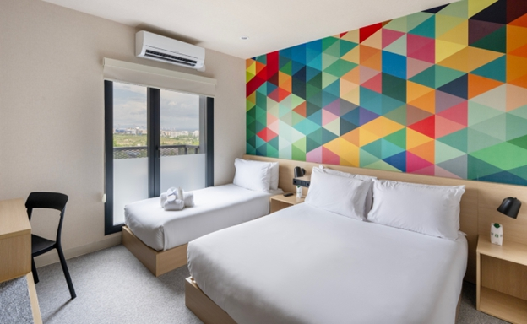

Hotel101’s signature 21 sqm HappyRoom equipped with a practical kitchenette featuring microwave, refrigerator and kettle, luggage rack, 55” TV, free high-speed internet, work desk, modern bidet toilet, strong water pressure, and premium Emma Sleep mattresses.

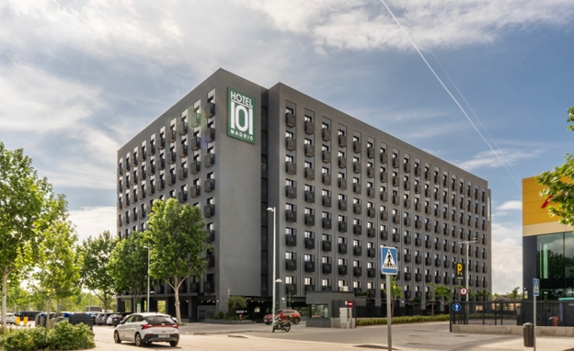

Latest Photo of 680-room Hotel101-Madrid

2

Forward Looking Statements

This document includes certain “forward-looking statements” within the meaning of securities laws of certain jurisdictions, including Section 27A of the Securities Act of 1933, as amended, and Section 21E of the Securities Exchange Act of 1934, as amended. All statements other than statements of historical facts contained in this document, including statements regarding the future financial position, business strategy, plans and objectives of management for future operations of Hotel101 Global Holdings Corp. (“HBNB”) and its subsidiaries (the “HBNB Group”), are forward-looking statements. In some cases, you can identify forward-looking statements by terminology such as “believe,” “may,” “estimate,” “continue,” “anticipate,” “intend,” “should,” “plan,” “set,” “expect,” “slated,” “scheduled,” “predict,” “potential” or the negative of these terms or other similar expressions. Forward-looking statements include, without limitation, HBNB’s expectations concerning anticipated revenues, the location, expected number of rooms and expected project completion dates of projects of HBNB and projects of its associate, Hotel of Asia, Inc., HBNB’s goals and vision, the outlook for the HBNB Group’s business, productivity, plans and goals for future operational improvements and capital investments, operational performance, future market conditions or economic performance and developments in the capital and credit markets and expected future financial performance, as well as any information concerning possible or assumed future results of operations of the HBNB Group. These forward-looking statements are based on the beliefs and assumptions of the management of HBNB. Although HBNB believes that such plans, intentions and expectations reflected in or suggested by these forward-looking statements are reasonable, HBNB cannot assure you that such plans, intentions or expectations will be achieved or realized. Forward-looking statements involve a number of risks, uncertainties and assumptions and actual results or events may differ materially from those projected or implied in those statements. Factors that may cause actual results to differ materially from current expectations include, but are not limited to, the HBNB Group’s ability manage, execute and implement its growth or expansion strategies; disagreements or disputes with the HBNB Group’s joint venture partners, including owners of pre-sold condotel units in Hotel101 hospitality projects, or the failure of such joint venture partners to perform their obligations; the HBNB Group’s exposure to risks associated with offering deferred payment schemes, including the risk of customer default; competition for the acquisition of land for new projects and risks relating to the management of its land bank; the HBNB Group’s ability to effectively compete in the highly competitive hospitality industry; decline or disruption in the travel and hospitality industries or economic downturn; liquidity risk; project cost and completion risks, and reputational risk and damage to the Hotel101 brand if projects or hotels do not meet customers’ requirements; risk relating to rights and titles over land; insurance; laws and regulations relating to real estate development and marketing activities and hotel operation and management activities; regulatory inquiries, investigations, litigation, and other disputes, including potential construction defects and other building-related claims; and other risks and uncertainties discussed in HBNB’s annual report for the year ended December 31, 2025 on Form 20-F (File No.: 001-42727) and under the heading “Risk Factors” in HBNB’s registration statement on Form F-4 (File No.: 333-287130) and other documents to be filed by HBNB from time to time with the U.S. Securities and Exchange Commission.

The foregoing list of factors is not exhaustive. Should one or more of these risks or uncertainties materialize, or should any of HBNB’s assumptions prove incorrect, actual results may vary in material respects from those projected in these forward-looking statements. There may be additional risks that are not presently known to HBNB or that HBNB currently believes are immaterial that could also cause actual results to differ from those contained in the forward-looking statements. HBNB cautions you against placing undue reliance on forward-looking statements, which reflect current beliefs and are based on information currently available as of the date hereof. Forward-looking statements set forth herein speak only as of the date of this document. HBNB does not undertake any obligation to revise forward-looking statements to reflect future events, changes in circumstances or changes in beliefs. In the event that any forward-looking statement is updated, no inference should be made that HBNB will make additional updates with respect to that statement, related matters or any other forward-looking statements.

3

