UNITED STATES
SECURITIES AND EXCHANGE COMMISSION
Washington, D.C. 20549

FORM 6-K

REPORT OF FOREIGN PRIVATE ISSUER
PURSUANT TO RULE 13a-16 OR 15d-16 UNDER
THE SECURITIES EXCHANGE ACT OF 1934

For the month of October 2026

Commission File Number: 001-42727

HOTEL101 GLOBAL HOLDINGS CORP.
(Name of Registrant)

20 Cecil Street #04-03
Plus Building
Singapore 049705
(Address of Principal Executive Office)

Indicate by check mark whether the registrant files or will file annual reports under cover of Form 20-F or Form 40-F.

Form 20-F ☒ Form 40-F ☐

Exhibit  Number |  | Description of Exhibit
99.1 |  | Press Release, dated October 20, 2026

1

SIGNATURES

Pursuant to the requirements of the Securities Exchange Act of 1934, the registrant has duly caused this report to be signed on its behalf by the undersigned, thereunto duly authorized.

 | Date: October 20, 2026
 | HOTEL101 GLOBAL HOLDINGS CORP.
 | By: | /s/ Rodolfo Ma. A. Ponferrada
 | Name: | Rodolfo Ma. A. Ponferrada
 | Title: | Authorized Signatory
 | By: | /s/ Jacy Ryan Tan Chua
 | Name: | Jacy Ryan Tan Chua
 | Title: | Authorized Signatory

[Signature Page to Form 6-K]

2

Exhibit 99.1

HOTEL101 GLOBAL ENTERS EGYPT – ITS FIRST ENTRY IN THE AFRICAN CONTINENT

Today, October 20, 2026: Hotel101 Global signs definitive binding agreements for a country-wide joint venture in Egypt, starting with an approx. 750-room Hotel101-Cairo West, Egypt.

Hotel101-Cairo West is set to have approx. 750 rooms on a 15,984 sqm site in Hay Al Ashgar along Ahmed Zewail Road, only around ten minutes from the Giza Pyramids and the Grand Egyptian Museum (GEM).

Hotel101-Cairo West is expected to generate 5.465 billion Egyptian pounds (US$102.09 million) in project value.

Hotel101-Cairo West is expected to be one of the top 3 largest hotels by room count in Cairo, Egypt.

Egypt is reported to have welcomed nearly 19 million tourists in 2025, while its total population is estimated at about 118.4 million.

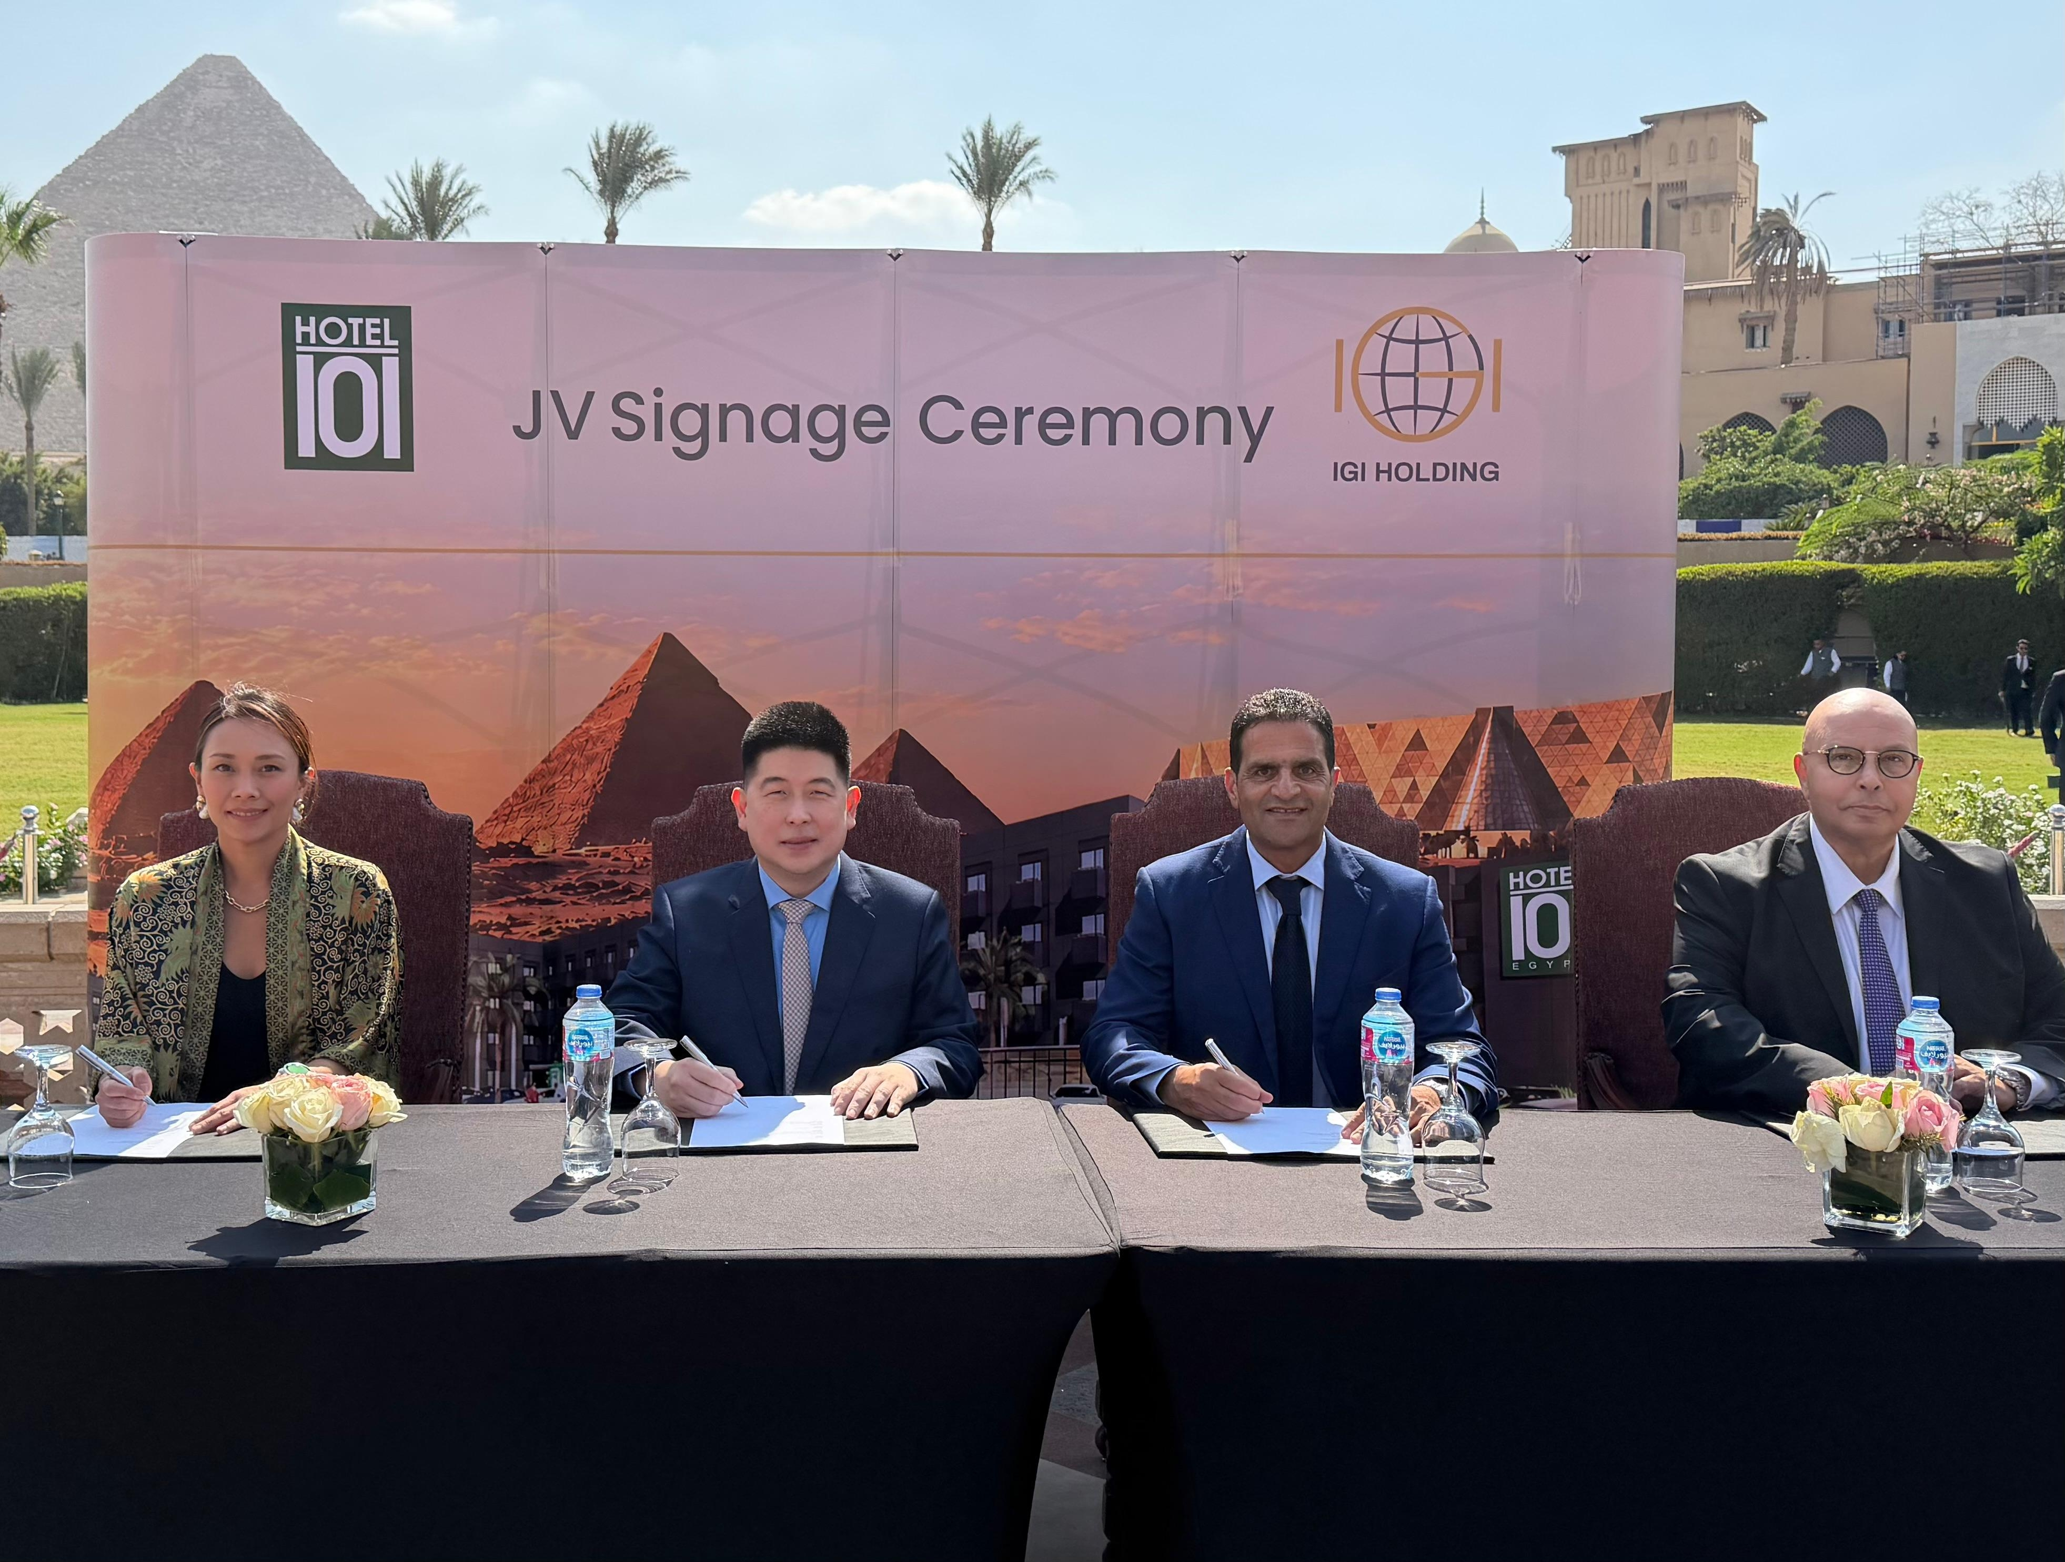

Hotel101 Founder Mr Edgar “Injap” Sia II and Mr Khaled Sheta of IGI Holding leads the Signing Ceremony with the world-famous Egypt Pyramids at the background.

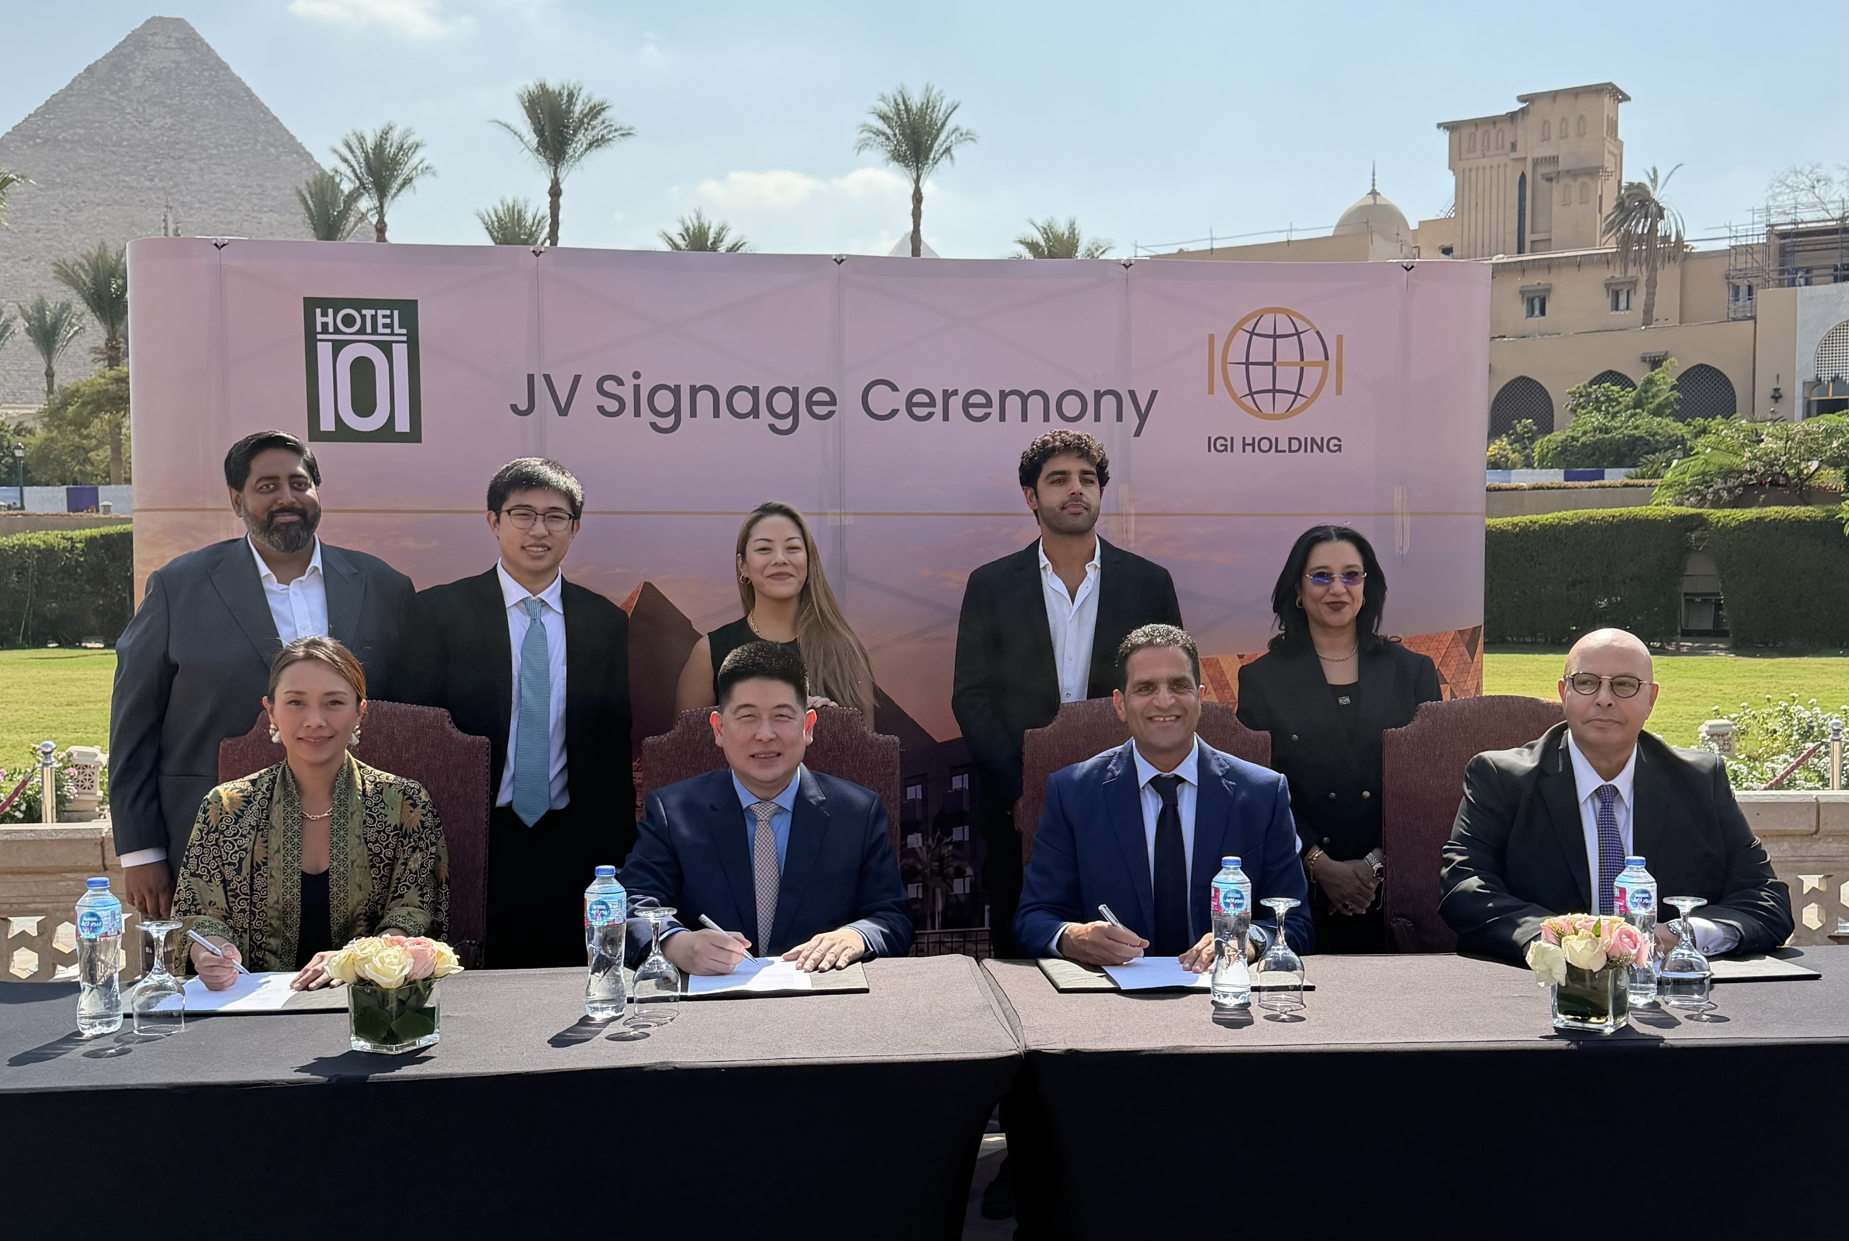

Hotel101 Global Founder Mr. Edgar “Injap” Sia II, CEO Ms. Hannah Yulo-Luccini, Chief Development Officer Ms. Catherine Chan, and Development Director Mr. Vivek Radhakrishnan, together with IGI Holding Vice Chairman Mr. Khaled Sheta, IGI Holding MD Mr. Nagy Mokhtar, IGI Holding Business Development Mr. Mostafa Sheta, and IGI Developments CEO Mr. Sherif Moustafa.

The country-wide joint venture for the expansion of Hotel101 into Egypt is between Hotel101 Global Pte. Ltd. and IGI Holding’s affiliates, WNTR Property and WNTR Hospitality. The Sheta family has built and led Egypt’s IGI Group since 1942. Over successive generations, the group has grown into a diversified enterprise with interests spanning textiles, FMCG, food and beverage, heavy industry, petroleum, construction, hospitality and real estate. Building on this foundation, IGI is now expanding into new sectors, with investments in industrial minerals and digital infrastructure. IGI Developments, the group’s real-estate arm, has been a pioneer of integrated residential compounds in Egypt since the mid-1990s. Over more than 30 years it has delivered multiple integrated communities; it holds a land portfolio of up to approximately 2.5 million square meters in strategic locations and currently houses more than 40,000 residents.

2

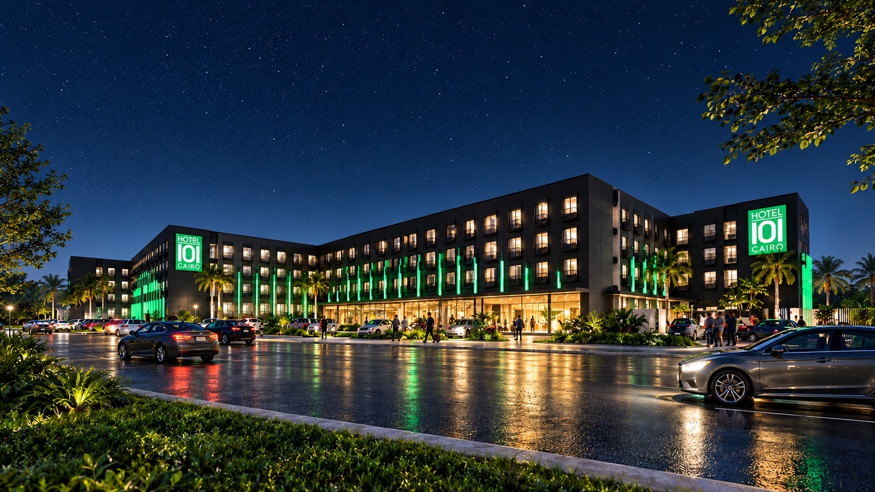

(Preliminary perspective of Hotel101-Cairo West Egypt, which is set to have approx. 750 rooms)

TODAY, OCTOBER 20, 2026 — Hotel101 Global Holdings Corp. (NASDAQ Ticker: HBNB) (“Hotel101” or “Hotel101 Global”), a leading asset-light, prop-tech hospitality platform pioneering a globally standardized “condotel” business model, listed on the Nasdaq Stock Exchange and a subsidiary of Philippine-listed DoubleDragon Corporation (PSE Ticker: DD), announces the signing of definitive binding agreements for a country-wide joint venture for the expansion of Hotel101 in Egypt, starting with the development of an approximately 750-room Hotel101 in Cairo, Egypt.

This expansion marks a significant milestone in the company’s global growth strategy, bringing its novel, globally standardized condotel business model to one of the Middle East and Africa’s most dynamic capital cities and a major cultural tourism gateway.

The hotel, to be named Hotel101-Cairo West, is planned to occupy a prime site in Hay Al Ashgar along Ahmed Zewail Road in 6th of October City, Giza. This strategic position is expected to offer guests connectivity via major arterial roads, including El Wahat Road and the Cairo Ring Road, with access to Sphinx International Airport and the wider Greater Cairo road network. The area has rapidly emerged as one of West Cairo’s key growth districts, known for its modern infrastructure, improving transport links, and strong mix of residential, commercial, and tourism developments, while sitting within the broader catchment of the Giza Pyramids and the Grand Egyptian Museum.

3

Key Location Advantages:

● Prime Ahmed Zewail Road Position: Located along Ahmed Zewail Road with direct access to El Wahat Road and links to the Cairo Ring Road. Upon completion, guests are expected to benefit from road connectivity and proximity to Sphinx International Airport, providing access for both domestic and international travelers.

● Proximity to Major Attractions: Situated within the West Cairo corridor serving the Giza Pyramids and Grand Egyptian Museum. The site is expected to offer a balance of modern urban development and cultural tourism demand, with easy access to key attractions, residential communities, and commercial amenities across Greater Cairo.

When completed, Hotel101-Cairo West is expected to generate a total project value of approximately 5.465 billion Egyptian Pounds (US$102.09 million) and is expected to be completed by 2029, forming part of Hotel101 Global’s global expansion strategy.

Hotel101-Cairo West is expected to offer 4-star amenities at affordable prices, including a ballroom, ample meeting spaces, and a conference center tailored for business events. Consistent with Hotel101’s offerings across its locations globally, guests are expected to enjoy modern rooms, 24/7 reception, all-day dining, swimming pools, a full-size gym, a business center, children’s playground, ample parking, luggage storage, and other amenities.

The development is subject to customary governmental, regulatory, corporate and other approvals.

About Hotel101 Global

Listed on Nasdaq (Ticker: HBNB) with a market capitalization of approximately US$1.1 billion as of October 16, 2026, Hotel101 is an asset-light, prop-tech hospitality platform pioneering a globally standardized “condotel” business model. Hotel101 aims to disrupt the global hotel and hospitality sector through its unique tech-enabled business model that positions it to generate revenues twice: first from the advance sale of individual hotel units during the construction phase; and second, from long-term recurring revenue derived from day-to-day hotel operations. The expansion of Hotel101 toward its long-term goal to operate in 100 countries globally is expected to be driven mainly by joint ventures and, in the future, license agreements with local developers in various countries worldwide.

The Hotel101 Global Group is advancing its global expansion plans toward its medium-term goal to be in 25 countries and its long-term goal of operating one million Hotel101 rooms in 100 countries globally.

4

Forward-Looking Statements

This document includes certain “forward-looking statements” within the meaning of securities laws of certain jurisdictions, including Section 27A of the Securities Act of 1933, as amended, and Section 21E of the Securities Exchange Act of 1934, as amended. All statements other than statements of historical facts contained in this document, including statements regarding the future financial position, business strategy, plans and objectives of management for future operations of Hotel101 Global Holdings Corp. (“HBNB”) and its subsidiaries (the “HBNB Group”), are forward-looking statements. In some cases, you can identify forward-looking statements by terminology such as “believe,” “may,” “estimate,” “continue,” “anticipate,” “intend,” “should,” “plan,” “set,” “expect,” “predict,” “potential” or the negative of these terms or other similar expressions. Forward-looking statements include, without limitation, HBNB’s expectations concerning anticipated sales revenue once fully sold and project value, the project location, expected number of rooms, expected project completion date and expansion goals, the outlook for the HBNB Group’s business, productivity, plans and goals for future operational improvements and capital investments, operational performance, future market conditions or economic performance and developments in the capital and credit markets and expected future financial performance, as well as any information concerning possible or assumed future results of operations of the HBNB Group. These forward-looking statements are based on the beliefs and assumptions of the management of HBNB. Although HBNB believes that such plans, intentions and expectations reflected in or suggested by these forward-looking statements are reasonable, HBNB cannot assure you that such plans, intentions or expectations will be achieved or realized. Forward-looking statements involve a number of risks, uncertainties and assumptions and actual results or events may differ materially from those projected or implied in those statements. Factors that may cause actual results to differ materially from current expectations include, but are not limited to, the HBNB Group’s ability to execute on its business model, potential business expansion opportunities in foreign countries and growth strategies, manage future growth, retain and expand customers’ use of its hotel services and attract new customers, and source and maintain talent; risks relating to joint venture partners, including owners of pre-sold condotel units in Hotel101 hospitality projects, who may have interests different from and may take actions that adversely affect the HBNB Group; risks relating to project cost and completion; risks relating to the HBNB Group’s sources of cash and cash resources; risks relating to offering deferred payment schemes, including the risk of customer default; the HBNB Group’s ability to effectively compete in the highly competitive hospitality industry; any declines or disruptions in the travel and hospitality industries or economic downturn; applicable laws and regulations to real estate development and marketing activities and hotel operation and management activities in the jurisdictions where the HBNB Group has operations or intends to expand into; and other risks and uncertainties discussed in HBNB’s annual report for the year ended December 31, 2025 on Form 20-F and under the heading “Risk Factors” in HBNB’s registration statement on Form F-4 (File No.: 333-287130) and other documents to be filed by HBNB from time to time with the U.S. Securities and Exchange Commission.

The foregoing list of factors is not exhaustive. Should one or more of these risks or uncertainties materialize, or should any of HBNB’s assumptions prove incorrect, actual results may vary in material respects from those projected in these forward-looking statements. There may be additional risks that are not presently known to HBNB or that HBNB currently believes are immaterial that could also cause actual results to differ from those contained in the forward-looking statements. HBNB cautions you against placing undue reliance on forward-looking statements, which reflect current beliefs and are based on information currently available as of the date hereof. Forward-looking statements set forth herein speak only as of the date of this document. HBNB does not undertake any obligation to revise forward-looking statements to reflect future events, changes in circumstances, or changes in beliefs. In the event that any forward-looking statement is updated, no inference should be made that HBNB will make additional updates with respect to that statement, related matters or any other forward-looking statements.

5

