UNITED STATES

SECURITIES AND EXCHANGE COMMISSION

Washington, D.C. 20549

FORM 6-K

REPORT OF FOREIGN PRIVATE ISSUER

PURSUANT TO RULE 13a-16 OR 15d-16 UNDER

THE SECURITIES EXCHANGE ACT OF 1934

For the month of July 2026

Commission File Number: 001-42727

HOTEL101 GLOBAL HOLDINGS CORP.

(Name of Registrant)

20 Cecil Street #04-03

Plus Building

Singapore 049705

(Address of Principal Executive Office)

Indicate by check mark whether the registrant files or will file annual reports under cover of Form 20-F or Form 40-F.

Form 20-F ☒ Form 40-F ☐

Exhibit
Number |  | Description of Exhibit
99.1 |  | Press Release, dated July 1, 2026

1

SIGNATURES

Pursuant to the requirements of the Securities Exchange Act of 1934, the registrant has duly caused this report to be signed on its behalf by the undersigned, thereunto duly authorized.

Date: July 1, 2026

HOTEL101 GLOBAL HOLDINGS CORP.

By: |  | /s/ Marriana H. Yulo
Name: |  | Marriana H. Yulo
Title: | Authorized Signatory
By: |  | /s/ Rodolfo Ma. A. Ponferrada
Name: |  | Rodolfo Ma. A. Ponferrada
Title: | Authorized Signatory

[Signature Page to Form 6-K]

2

Exhibit 99.1

JULY 1, 2026; HOTEL101 GLOBAL ANNOUNCES DEFINITIVE BINDING AGREEMENTS SIGNED FOR THE DEVELOPMENT OF HOTEL101 IN BANGKOK, THAILAND

HOTEL101-BANGKOK IS SET TO HAVE APPROX. 770 ROOMS TO RISE IN AN 8,336 SQM SITE ALONG PHAHON YOTHIN ROAD, NEAR DON MUEANG INTERNATIONAL AIRPORT AND BESIDE THE YAEK KOR POR AOR BTS STATION.

HOTEL101-BANGKOK IS EXPECTED TO GENERATE APPROX. 1.925 BILLION BAHT (US$58 MILLION) IN SALES REVENUE

HOTEL101-BANGKOK WITH ITS 8,336 SQM PRIME SITE AND APPROX. 770 ROOMS IS EXPECTED TO BE ONE OF THE TOP 3 LARGEST HOTELS IN BANGKOK BY ROOMCOUNT
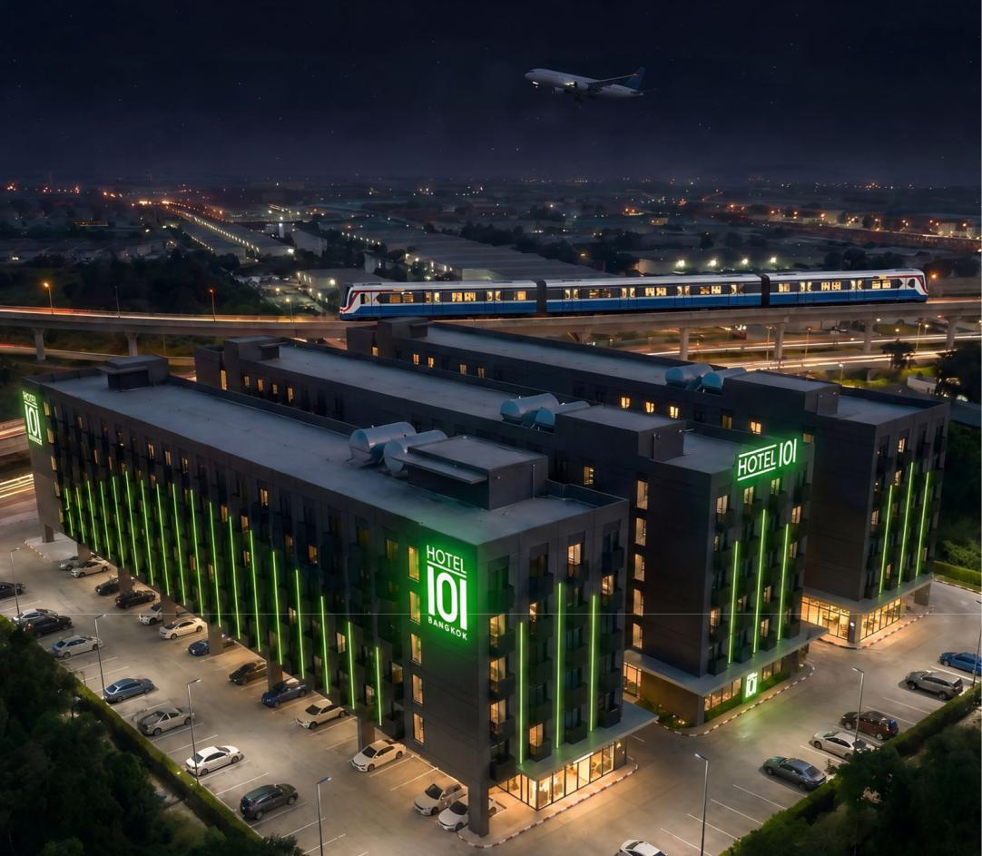

(Preliminary perspective of Hotel101-Bangkok Thailand, which is set to have approx. 770 rooms)



Hotel101 Global and Origin Property teams led by Hotel101 Global Founder Mr. Edgar “Injap” Sia II, Executive Chairman Mr. Rodolfo “Pong” Ponferrada, Chief Development Officer Ms. Catherine Chan, Legal Services Director Mr. Carlos D. Agaña, and Strategic Partnerships Director Ms. Jane Wang, together with Origin Property PCL CEO Mr. Peerapong Jaroon-ek and Co-CEO Mr. Pitipong Trinuruk, during the signing ceremony for Hotel101-Bangkok held at Origin Property’s Headquarters in Bangkok, Thailand.

The project will be jointly developed by Hotel101 Global and Origin Hotel, subsidiary under Origin Property PCL (ORI, listed on the Stock Exchange of Thailand) (“Origin Property”), which was established in 2009 as a leading property developer specializing in stylish condominiums located near BTS Skytrain routes and expressways, offering residents convenient access to transportation. Since its founding, Origin Property has developed numerous quality projects known for unique designs, functional layouts, and strong after-sales service.

SINGAPORE JULY 1, 2026 -- Hotel101 Global Holdings Corp. (NASDAQ Ticker: HBNB) (“Hotel101” or “Hotel101 Global”), a leading asset-light, prop-tech hospitality platform pioneering a global standardized “condotel” business model listed on the Nasdaq Stock Exchange and a subsidiary of Philippine-listed DoubleDragon Corporation (PSE Ticker: DD), announces the signing of definitive binding agreements for the joint venture development of an approx. 770-room Hotel101 in Bangkok, Thailand. This expansion marks a significant milestone in the company’s global growth strategy, bringing its novel, globally standardized condotel business model to one of Southeast Asia’s most dynamic capital cities and major transportation hubs.

The hotel is expected to occupy a prime 8,336 sqm site along Phahon Yothin Road, near Don Mueang International Airport and beside the Yaek Kor Por Aor BTS Station. This strategic position is expected to offer connectivity and convenient access to Bangkok’s vibrant northern corridor. The area has emerged as one of Bangkok’s key growth districts, known for its modern infrastructure, excellent transport links, and strong mix of commercial, residential, and tourism developments.

Key Location Advantages:

- Prime Phahon Yothin Road Position: Located beside the Yaek Kor Por Aor BTS Station and near Don Mueang International Airport. Guests are expected to benefit from seamless connectivity via the BTS Skytrain system and proximity to the airport, providing convenient access for both domestic and international travelers.

- Proximity to Major Attractions: Surrounded by vibrant local attractions including Save One Go Night Market. The site offers an excellent balance of urban energy, shopping, dining, and green spaces, with easy access to Chatuchak Market, the city center, and major Bangkok attractions.

2

Hotel101-Bangkok is expected to generate approx. 1.925 billion Baht (US$58 million) in sales revenue once fully sold, and is expected to be completed by 2029, forming part of Hotel101 Global’s global expansion strategy.

Hotel101-Bangkok is expected to offer 4-star amenities at affordable prices, including ample meeting spaces and a conference center tailored for business events. Consistent with Hotel101’s offerings across its locations globally, guests are expected to be able to enjoy modern rooms, 24/7 reception, all-day dining, swimming pool, full-size gym, business center, children’s pool, ample parking, luggage storage, and other amenities.

The development is subject to customary regulatory approvals.

About Hotel101 Global

Listed on Nasdaq (Ticker: HBNB) with a market capitalization of approx. US$1.2 billion as of June 30, 2026. Hotel101 is an asset-light, prop-tech hospitality platform pioneering a global standardized “condotel” business model. Hotel101 aims to disrupt the global hotel and hospitality sector through its unique tech-enabled business model that positions it to generate revenues twice: first from the advance sale of individual hotel units during the construction phase; and second, from long-term recurring revenue derived from day-to-day hotel operations. The expansion of Hotel101 towards its long-term goal to operate in 100 countries globally is expected to be driven mainly by joint ventures and license agreements with local developers in various countries worldwide.

The Hotel101 Global Group is advancing its global expansion plans towards its medium-term goal to be in 25 countries and its long-term goal of operating one million Hotel101 rooms in 100 countries globally.

3

Forward Looking Statements

This document includes certain “forward-looking statements” within the meaning of securities laws of certain jurisdictions, including Section 27A of the Securities Act of 1933, as amended, and Section 21E of the Securities Exchange Act of 1934, as amended. All statements other than statements of historical facts contained in this document, including statements regarding the future financial position, business strategy, plans and objectives of management for future operations of Hotel101 Global Holdings Corp. (“HBNB”) and its subsidiaries (the “HBNB Group”), are forward-looking statements. In some cases, you can identify forward-looking statements by terminology such as “believe,” “may,” “estimate,” “continue,” “anticipate,” “intend,” “should,” “plan,” “set,” “expect,” “predict,” “potential” or the negative of these terms or other similar expressions. Forward-looking statements include, without limitation, HBNB’s expectations concerning anticipated sales revenues, the location, expected number of rooms and expected project completion dates, the outlook for the HBNB Group’s business, productivity, plans and goals for future operational improvements and capital investments, operational performance, future market conditions or economic performance and developments in the capital and credit markets and expected future financial performance, as well as any information concerning possible or assumed future results of operations of the HBNB Group. These forward-looking statements are based on the beliefs and assumptions of the management of HBNB. Although HBNB believes that such plans, intentions and expectations reflected in or suggested by these forward-looking statements are reasonable, HBNB cannot assure you that such plans, intentions or expectations will be achieved or realized. Forward-looking statements involve a number of risks, uncertainties and assumptions and actual results or events may differ materially from those projected or implied in those statements. Factors that may cause actual results to differ materially from current expectations include, but are not limited to, the HBNB Group’s ability to execute on its business model, potential business expansion opportunities in foreign countries and growth strategies, manage future growth, retain and expand customers’ use of its hotel services and attract new customers, and source and maintain talent; risks relating to joint venture partners, including owners of pre-sold condotel units in Hotel101 hospitality projects, who may have interests different from and may take actions that adversely affect the HBNB Group; risks relating to project cost and completion; risks relating to the HBNB Group’s sources of cash and cash resources; risks relating to offering deferred payment schemes, including the risk of customer default; the HBNB Group’s ability to effectively compete in the highly competitive hospitality industry; any declines or disruptions in the travel and hospitality industries or economic downturn; applicable laws and regulations to real estate development and marketing activities and hotel operation and management activities in the jurisdictions where the HBNB Group has operations or intends to expand into; and other risks and uncertainties discussed in HBNB’s annual report for the year ended December 31, 2025 on Form 20-F and under the heading “Risk Factors” in HBNB’s registration statement on Form F-4 (File No.: 333-287130) and other documents to be filed by HBNB from time to time with the U.S. Securities and Exchange Commission.

The foregoing list of factors is not exhaustive. Should one or more of these risks or uncertainties materialize, or should any of HBNB’s assumptions prove incorrect, actual results may vary in material respects from those projected in these forward-looking statements. There may be additional risks that are not presently known to HBNB or that HBNB currently believes are immaterial that could also cause actual results to differ from those contained in the forward-looking statements. HBNB cautions you against placing undue reliance on forward-looking statements, which reflect current beliefs and are based on information currently available as of the date hereof. Forward-looking statements set forth herein speak only as of the date of this document. HBNB does not undertake any obligation to revise forward-looking statements to reflect future events, changes in circumstances, or changes in beliefs. In the event that any forward-looking statement is updated, no inference should be made that HBNB will make additional updates with respect to that statement, related matters or any other forward-looking statements.

4

