UNITED STATES

SECURITIES AND EXCHANGE COMMISSION

Washington, D.C. 20549

FORM 6-K

REPORT OF FOREIGN PRIVATE ISSUER

PURSUANT TO RULE 13a-16 OR 15d-16 UNDER

THE SECURITIES EXCHANGE ACT OF 1934

For the month of November 2026

Commission File Number: 001-42727

HOTEL101 GLOBAL HOLDINGS CORP.

(Name of Registrant)

20 Cecil Street #04-03

Plus Building

Singapore 049705

(Address of Principal Executive Office)

Indicate by check mark whether the registrant files or will file annual reports under cover of Form 20-F or Form 40-F.

Form 20-F ☒ Form 40-F ☐

Exhibit
Number |  | Description of Exhibit
99.1 |  | Press Release, dated November 2, 2026

1

SIGNATURES

Pursuant to the requirements of the Securities Exchange Act of 1934, the registrant has duly caused this report to be signed on its behalf by the undersigned, thereunto duly authorized.

Date: November 2, 2026

HOTEL101 GLOBAL HOLDINGS CORP.

By: | /s/ Marriana H. Yulo
Name: | Marriana H. Yulo
Title: | Authorized Signatory
By: | /s/ Rodolfo Ma. A. Ponferrada
Name: | Rodolfo Ma. A. Ponferrada
Title: | Authorized Signatory

[Signature Page to Form 6-K]

2

Exhibit 99.1

HOTEL101-MADRID HITS RECORD HIGH OF US$3.28 MILLION MONTHLY RECURRING REVENUES FROM OCTOBER 1 TO 31, 2026 WITH 97.41% OCCUPANCY

Hotel101-Madrid, the 680-room global prototype, has recorded its strongest monthly performance to date, providing further support for the Company’s asset-light condotel model as it advances its international expansion.
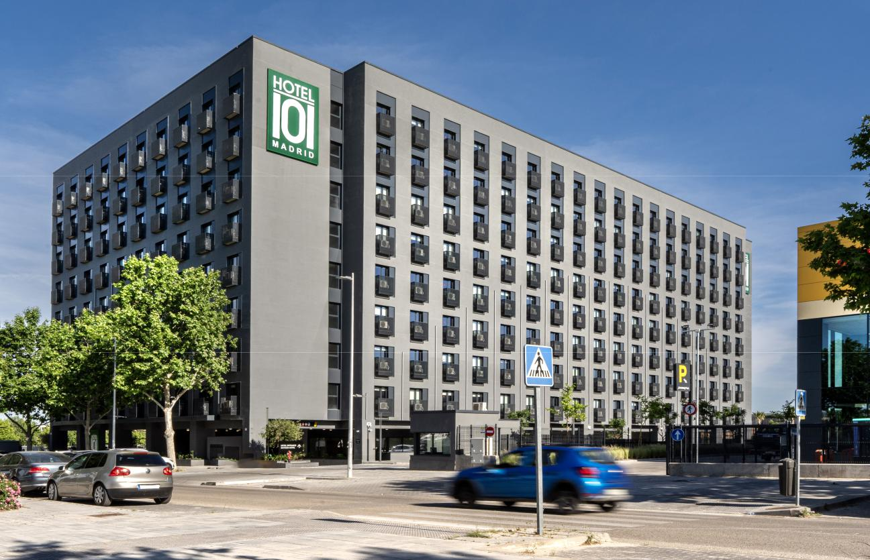

Latest Photo of 680-room Hotel101-Madrid in Valdebebas, Madrid, Spain

November 2, 2026 – Hotel101 Global Holdings Corp. (NASDAQ: HBNB) (“Hotel101 Global,” “Hotel101,” “HBNB” or the “Company”) today announced that the monthly performance of its 680-room Hotel101-Madrid has significantly exceeded the Company’s expectations. In October 2026,

Hotel101-Madrid achieved a record high of €2.93¹ million (equivalent to approx. US$3.28 million) in recurring revenues from stays during the month, with average occupancy of 97.41%.

This record performance reflects the continued momentum and exceptionally strong demand for Hotel101-Madrid, the first Hotel101-branded property to operate outside the Philippines, which opened in March 2026. The Company believes the results provide clear evidence of robust underlying demand in a major European market and demonstrates Hotel101-Madrid’s ability to generate recurring revenues at scale. Management believes this property’s October performance is indicative of Hotel101’s potential to contribute meaningful annual recurring hotel revenues and further validates the Company’s asset-light, prop-tech hospitality model and its emphasis on long-term, recurring revenue generation across the Hotel101 global portfolio.

Key Operating Highlights – Hotel101-Madrid (October 2026)

- Monthly recurring revenue from October 2026 stays: €2,929,778¹ (a property record for any single month)

- Average occupancy: 97.41%

- Property size: 680 standardized HappyRooms

The Company believes these results reflect the effectiveness of Hotel101’s globally standardized “HappyRoom” concept and tech-enabled operating platform in attracting demand. The high occupancy also benefits unit owners, who collectively receive 30% of monthly gross room revenues net of applicable taxes and statutory charges, distributed equally across all units and paid by the 16th day of the following month.

Hotel101-Madrid serves as the global prototype of the Hotel101 concept and primary operating springboard for the Company’s international expansion. Located in the dynamic Valdebebas district, just minutes from Adolfo Suárez Madrid-Barajas International Airport and IFEMA, one of Europe’s largest convention and exhibition centers, the 680-room property sits adjacent to the Real Madrid Sports City and the Formula 1 Spanish Grand Prix circuit, placing it at the heart of Madrid’s premier sports and events zone.

Hotel101-Madrid has demonstrated strong international guest appeal, earning a 9.1 “Exceptional” rating based on more than 9,700 reviews across major online travel agencies as of October 31, 2026. Since opening in March 2026 through October 31, 2026, arrivals have been led by guests from Spain (39%), the United States (7%), Portugal (4%), China (3%), and Mexico (3%), reflecting strong appeal across multiple continents. Europe has accounted for nearly two-thirds of all arrivals (63.3%), followed by Latin America (16.1%), North America (8.5%), and Asia (6.2%). With guests from over 100 nationalities, including a growing number of Filipinos (0.55% of the more than 95,500 arrivals since opening in March 2026), Hotel101-Madrid has rapidly established itself as an international destination.

Management expects Hotel101-Madrid’s performance to support the replication of the Hotel101 business model through joint ventures and, in the future, license agreements, advancing Hotel101 Global’s long-term vision of developing one million standardized rooms across 100 countries and its aspiration to become one of the top hotel brands globally.

About Hotel101 Global

Listed on Nasdaq (Ticker: HBNB) with a market capitalization of approx. US$1.11 billion as of October 30, 2026, Hotel101 is an asset-light, prop-tech hospitality platform pioneering a globally standardized “condotel” business model. Hotel101 aims to disrupt the global hotel and hospitality sector through its unique tech-enabled business model that positions it to generate revenues twice: first from the advance sale of individual hotel units during the construction phase; and second, from long-term recurring revenue derived from day-to-day hotel operations. The expansion of Hotel101 toward its long-term goal to operate in 100 countries globally is expected to be driven mainly by joint ventures and, in the future, license agreements with local developers in various countries worldwide.

Hotel101 is advancing its global expansion plans toward its medium-term goal to be in 25 countries and its long-term goal of operating one million Hotel101 rooms in 100 countries globally.

- The monthly recurring revenue figure in this release is a preliminary, unaudited management estimate based on information available as of the date of this release, relates only to stays at Hotel101-Madrid in October 2026 and is subject to change.

2

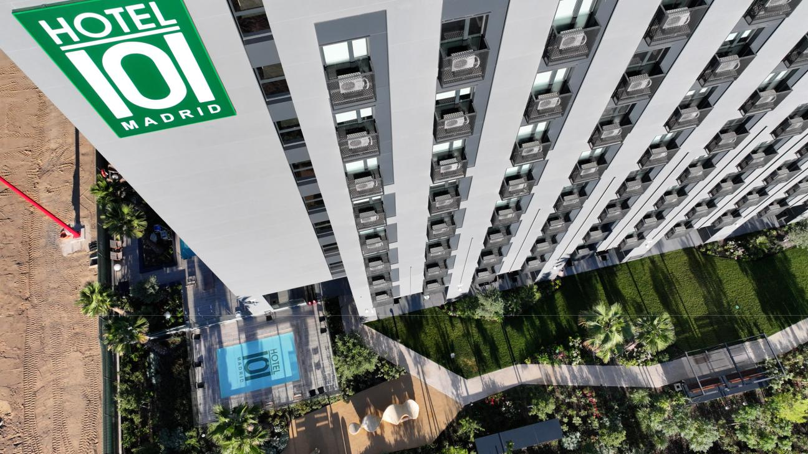

Latest Photo of 680-room Hotel101-Madrid in Valdebebas, Madrid, Spain

3

Forward-Looking Statements

This document includes certain “forward-looking statements” within the meaning of securities laws of certain jurisdictions, including Section 27A of the Securities Act of 1933, as amended, and Section 21E of the Securities Exchange Act of 1934, as amended. All statements other than statements of historical facts contained in this document, including statements regarding the future financial position, business strategy, plans and objectives of management for future operations of Hotel101 Global Holdings Corp. (“HBNB”) and its subsidiaries (the “HBNB Group”), are forward-looking statements. In some cases, you can identify forward-looking statements by terminology such as “believe,” “may,” “estimate,” “continue,” “anticipate,” “intend,” “should,” “plan,” “set,” “expect,” “aim,” “goal,” “predict,” “potential” or the negative of these terms or other similar expressions. Forward-looking statements include, without limitation, HBNB’s expectations concerning anticipated recurring hotel revenues, the replication of its business model, expected number of rooms and expansion goals, the outlook for the HBNB Group’s business, productivity, plans and goals for future operational improvements and capital investments, operational performance, future market conditions or economic performance and developments in the capital and credit markets and expected future financial performance, as well as any information concerning possible or assumed future results of operations of the HBNB Group. These forward-looking statements are based on the beliefs and assumptions of the management of HBNB. Although HBNB believes that such plans, intentions and expectations reflected in or suggested by these forward-looking statements are reasonable, HBNB cannot assure you that such plans, intentions or expectations will be achieved or realized. Forward-looking statements involve a number of risks, uncertainties and assumptions and actual results or events may differ materially from those projected or implied in those statements. Results for any single month are not necessarily indicative of results for any future period. Factors that may cause actual results to differ materially from current expectations include, but are not limited to, the HBNB Group’s ability to execute on its business model, potential business expansion opportunities in foreign countries and growth strategies, manage future growth, retain and expand customers’ use of its hotel services and attract new customers, and source and maintain talent; risks relating to joint venture partners, including owners of pre-sold condotel units in Hotel101 hospitality projects, who may have interests different from and may take actions that adversely affect the HBNB Group; risks relating to project cost and completion; risks relating to the HBNB Group’s sources of cash and cash resources; risks relating to offering deferred payment schemes, including the risk of customer default; the HBNB Group’s ability to effectively compete in the highly competitive hospitality industry; seasonality and fluctuations in hotel demand; any declines or disruptions in the travel and hospitality industries or economic downturn; applicable laws and regulations to real estate development and marketing activities and hotel operation and management activities in the jurisdictions where the HBNB Group has operations or intends to expand into; and other risks and uncertainties discussed in HBNB’s annual report for the year ended December 31, 2025 on Form 20-F and under the heading “Risk Factors” in HBNB’s registration statement on Form F-4 (File No.: 333-287130) and other documents to be filed by HBNB from time to time with the U.S. Securities and Exchange Commission.

The foregoing list of factors is not exhaustive. Should one or more of these risks or uncertainties materialize, or should any of HBNB’s assumptions prove incorrect, actual results may vary in material respects from those projected in these forward-looking statements. There may be additional risks that are not presently known to HBNB or that HBNB currently believes are immaterial that could also cause actual results to differ from those contained in the forward-looking statements. HBNB cautions you against placing undue reliance on forward-looking statements, which reflect current beliefs and are based on information currently available as of the date hereof. Forward-looking statements set forth herein speak only as of the date of this document. HBNB does not undertake any obligation to revise forward-looking statements to reflect future events, changes in circumstances, or changes in beliefs. In the event that any forward-looking statement is updated, no inference should be made that HBNB will make additional updates with respect to that statement, related matters or any other forward-looking statements.

4

