UNITED STATES

SECURITIES AND EXCHANGE COMMISSION

Washington, D.C. 20549

FORM 6-K

REPORT OF FOREIGN PRIVATE ISSUER

PURSUANT TO RULE 13a-16 OR 15d-16 UNDER

THE SECURITIES EXCHANGE ACT OF 1934

For the month of April 2026

Commission File Number: 001-42727

HOTEL101 GLOBAL HOLDINGS CORP.

(Name of Registrant)

20 Cecil Street #04-03

Plus Building

Singapore 049705

(Address of Principal Executive Office)

Indicate by check mark whether the registrant files or will file annual reports under cover of Form 20-F or Form 40-F.

Form 20-F ☒ Form 40-F ☐

Exhibit
Number |  | Description of Exhibit
99.1 |  | Press Release, dated April 28, 2026

1

SIGNATURES

Pursuant to the requirements of the Securities Exchange Act of 1934, the registrant has duly caused this report to be signed on its behalf by the undersigned, thereunto duly authorized.

Date: April 28, 2026

HOTEL101 GLOBAL HOLDINGS CORP.

By: | /s/ Marriana H. Yulo
Name: | Marriana H. Yulo
Title: | Authorized Signatory
By: | /s/ Rodolfo Ma. A. Ponferrada
Name: | Rodolfo Ma. A. Ponferrada
Title: | Authorized Signatory

[Signature Page to Form 6-K]

2

Exhibit 99.1

Hotel101 Global Announces Strong Booking Performance at Hotel101-Madrid

SINGAPORE, April 28, 2026 – Hotel101 Global Holdings Corp. (NASDAQ Ticker: HBNB) (“Hotel101 Global,” “Hotel101,” “HBNB” or the “Company”) today announced robust early booking performance for its 680-room Hotel101-Madrid, the first Hotel101-branded property to operate outside the Philippines, which officially opened in March 2026.

Since it began officially accepting bookings on March 10, 2026, Hotel101-Madrid has generated more than 45,000 hotel night bookings, representing approximately €5,443,000 in hotel revenue. The Company believes this successful start bodes well for continued recurring revenue generation from Hotel101-Madrid.

Hotel101-Madrid has been designated as an “Official Hotel” partner for the Formula 1 Spanish Grand Prix from 2026 to 2035 through an exclusive agreement with MATCH Hospitality AG. Hotel101-Madrid is one of the top five largest hotels in Madrid by room count. Located on a 6,593-square-meter site in Valdebebas, Madrid, it is strategically positioned adjacent to the new Formula 1 Spanish Grand Prix circuit, overlooking the iconic semicircular Turn 12 titled “La Monumental”. The property offers convenient accessibility, located approximately a three-minute walk to Valdebebas Train Station, four minutes to the IFEMA convention complex, five minutes to the Real Madrid Sports Complex and seven minutes to the Adolfo Suárez Madrid-Barajas International Airport.

The hotel features modern amenities, including an all-day dining restaurant, HBNB Kitchen by award-winning La Sucursal, two swimming pools, a fitness center, a children’s playground, 24/7 reception, a business center, function rooms and a proprietary Hotel101 app that supports seamless guest services, including digital check-in and digital key access.

2026 Expansion Highlights

HBNB believes that 2026 is on track to be the year with the highest number of Hotel101-branded room openings in the history of HBNB and its subsidiaries and associates, with an estimated total of 2,229 additional hotel rooms slated to become operational this year, comprising 680 rooms in Madrid,
Spain, which recently opened in March 2026, to be followed by 519⁽¹⁾ rooms in Davao, Philippines⁽²⁾, 548⁽¹⁾ rooms in Cebu, Philippines⁽²⁾ and 482⁽¹⁾ rooms in Niseko, Hokkaido, Japan.

Hotel101-Niseko, a 482-room⁽¹⁾ hotel, is expected to be one of the largest hotel projects in the Niseko area by room count upon completion. The project is expected to mark the Company’s formal entry into the Japanese market and to generate recurring revenues in Japanese Yen, with operations expected to commence in December 2026.

Footnotes:

- Expected number of rooms are based on HBNB’s estimates.

- Hotel101-Davao and Hotel101-Cebu are under development by HBNB’s associate, Hotel of Asia, Inc. (“HOA”). HOA is not consolidated in HBNB’s financial statements.

About Hotel101 Global

Listed on Nasdaq (Ticker: HBNB) with a market capitalization of approx. US$1.5 billion as of April 26, 2026. Hotel101 is an asset-light, prop-tech hospitality platform pioneering a global standardized “condotel” business model. Hotel101 aims to disrupt the global hotel and hospitality sector through its unique tech-enabled business model that positions it to generate revenues twice: first from the advance sale of individual hotel units during the construction phase; and second, from long-term recurring revenue derived from day-to-day hotel operations. The expansion of Hotel101 towards its long-term goal and vision to operate 1 million rooms in 100 countries globally is expected to be driven mainly by joint ventures and license agreements with local developers in various countries worldwide.
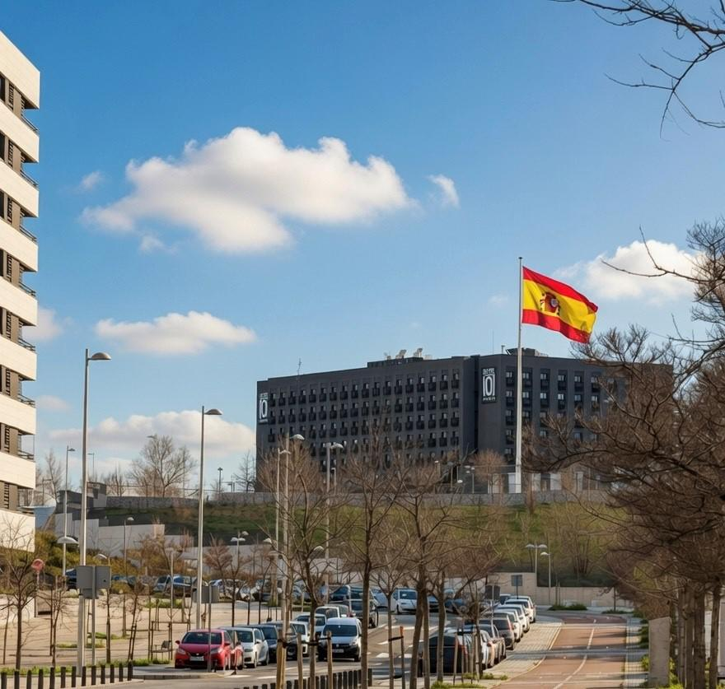

Actual photo of the 680-room Hotel101 in Madrid, Spain

2

Forward Looking Statements

This document includes certain “forward-looking statements” within the meaning of securities laws of certain jurisdictions, including Section 27A of the Securities Act of 1933, as amended, and Section 21E of the Securities Exchange Act of 1934, as amended. All statements other than statements of historical facts contained in this document, including statements regarding the future financial position, business strategy, plans and objectives of management for future operations of Hotel101 Global Holdings Corp. (“HBNB”) and its subsidiaries (the “HBNB Group”), are forward-looking statements. In some cases, you can identify forward-looking statements by terminology such as “believe,” “may,” “estimate,” “continue,” “anticipate,” “intend,” “should,” “plan,” “set,” “expect,” “slated,” “scheduled,” “predict,” “potential” or the negative of these terms or other similar expressions. Forward-looking statements include, without limitation, HBNB’s expectations concerning anticipated revenues, the location, expected number of rooms and expected project completion dates of projects of HBNB and projects of its associate, Hotel of Asia, Inc., HBNB’s goals and vision, the outlook for the HBNB Group’s business, productivity, plans and goals for future operational improvements and capital investments, operational performance, future market conditions or economic performance and developments in the capital and credit markets and expected future financial performance, as well as any information concerning possible or assumed future results of operations of the HBNB Group. These forward-looking statements are based on the beliefs and assumptions of the management of HBNB. Although HBNB believes that such plans, intentions and expectations reflected in or suggested by these forward-looking statements are reasonable, HBNB cannot assure you that such plans, intentions or expectations will be achieved or realized. Forward-looking statements involve a number of risks, uncertainties and assumptions and actual results or events may differ materially from those projected or implied in those statements. Factors that may cause actual results to differ materially from current expectations include, but are not limited to, the HBNB Group’s ability to execute on its business model, potential business expansion opportunities in foreign countries and growth strategies, manage future growth, retain and expand customers’ use of its hotel services and attract new customers, and source and maintain talent; risks relating to joint venture partners, including owners of pre-sold condotel units in Hotel101 hospitality projects, who may have interests different from and may take actions that adversely affect the HBNB Group; risks relating to project cost and completion; risks relating to the HBNB Group’s sources of cash and cash resources; risks relating to offering deferred payment schemes, including the risk of customer default; the HBNB Group’s ability to effectively compete in the highly competitive hospitality industry; any declines or disruptions in the travel and hospitality industries or economic downturn; applicable laws and regulations to real estate development and marketing activities and hotel operation and management activities in the jurisdictions where the HBNB Group has operations or intends to expand into; and other risks and uncertainties discussed in HBNB’s Shell Company Report on Form 20-F and under the heading “Risk Factors” in HBNB’s registration statement on Form F-4 (File No.: 333-287130) and other documents to be filed by HBNB from time to time with the U.S. Securities and Exchange Commission.

The foregoing list of factors is not exhaustive. Should one or more of these risks or uncertainties materialize, or should any of HBNB’s assumptions prove incorrect, actual results may vary in material respects from those projected in these forward-looking statements. There may be additional risks that are not presently known to HBNB or that HBNB currently believes are immaterial that could also cause actual results to differ from those contained in the forward-looking statements. HBNB cautions you against placing undue reliance on forward-looking statements, which reflect current beliefs and are based on information currently available as of the date hereof. Forward-looking statements set forth herein speak only as of the date of this document. HBNB does not undertake any obligation to revise forward-looking statements to reflect future events, changes in circumstances or changes in beliefs. In the event that any forward-looking statement is updated, no inference should be made that HBNB will make additional updates with respect to that statement, related matters or any other forward-looking statements.

3

